Feature Image: Don’t miss out—see if a pre-owned watch fits your portfolio.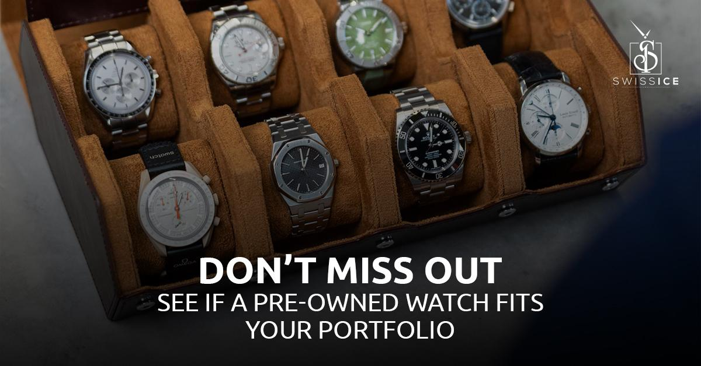

Title: Are Pre-Owned Luxury Watches a Good Long-Term Investment

Focus Keyword: Pre-Owned Luxury Watches
Secondary Keywords:
Pre-Owned Watches near me
best luxury watch brands
best watch brands
best watches for men
best luxury watch brands for men

Internal Link
luxury watches: https://swissiceco.com/pages/watches
luxury men watch: https://swissiceco.com/

Meta Description:
Learn why pre-owned luxury watches from Rolex, Patek Philippe, and Audemars Piguet can be smart investments with Swiss Ice Co offering authenticated timepieces.

Are Pre-Owned Luxury Watches a Good Long-Term Investment H1
Hi there! We offer the finest pre-owned luxury watches at Swiss Ice Co. Today, let’s explore a topic that comes to mind for every watch lover. Is it a smart idea to buy a luxury watch that was previously owned? Let mus be open with you. We’ll stick to the facts and skip any fancy talk. Let’s get started..

What are the Reasons to Look Into Pre-Owned Luxury Watches H2
First, let’s clarify that we are not suggesting that all second-hand watches can secure your retirement plan. Several luxury watches have seen their value preserved or increase over the years. Here’s why:
- Lower Entry Point: The moment you buy a new luxury men watch, it can quickly drop in value by 20-30%. Pre-owned pieces? They’ve already taken that hit. You tend to purchase at or near the floor price, allowing you more space for growth.
- Slower Depreciation: Rolex, Patek Philippe, and Audemars Piguet watches lose their value more slowly (or may actually increase in value) than freshly released models from other brands. WatchCharts found in a study that the prices of pre-owned top-level watch brands went up by 8-12% each year from 2020 to 2023, exceeding the gains of traditional stocks.
- Rarity & Discontinuation: Hard-to-find models are becoming more common because production has stopped for many of them. The limited availability of raw materials pressures demand and drives up prices over time. Within just a six-month period after they were discontinued, pre-owned Rolex “Pepsi” GMT-Master II models increased in price by 25%.

Best Luxury Watch Brands for Investment H2
Not all watches are equal. Go for the best watch brands that retain their worth.
- Rolex: The Submariner, Daytona, and GMT-Master have earned the title of icons. People still pay more for secondhand Rolex watches than they do for brand-new ones. In early 2025, Vintage Submariners from the 1960s will be available at a variety of prices that will leave you amazed.
- Patek Philippe: Nautilus and Aquanaut belong in the highest level of watchmaking. Because of their lasting appeal to many generations, demand for these watches does not fade.
- Audemars Piguet: Because of its well-known design and background, the Royal Oak remains highly sought-after. Strong returns were seen from the discontinued product in 2022, as its value doubled in just two years.
- Omega: Both Speedmasters and Seamasters, especially those from the past, keep their value very well.
- Tudor: The Black Bay Fifty-Eight, launched in 2018, is already priced at a 20% premium in the pre-owned market.
The reason these brands are considered the greatest is because they are reliable and sought across the world.

Why Choosing a Pre-Owned Watch Is a Sensible Option H2
These three aspects help us recognize a true investment rather than a good deal:

1. Brand Reputation H3
Stick with household names. Buyers tend to pick a pre-owned Rolex over a brand that is not well-known. While Vacheron Constantin and Jaeger-LeCoultre do not reach a large crowd, they hold their own in the market.

2. Model Popularity H3
Sports watches tend to bring in more money when resold, compared to dress watches. Focus on models that people are truly obsessed with. For example, the Moonwatch Speedmaster saw a price jump after NASA announced it was planning a return to the moon in 2024.

3. Condition & Authenticity H3
Scratches, swapped parts, or lacking documents can drop the car’s worth. Purchase only those pre-owned watches that come with official service records. Rarer cases without modifications or cases as produced by the manufacturer tend to be more expensive for dealers.

What Could Go Wrong? H2
It’s important to know that buying a pre-owned luxury watch carries some risk. Here’s what to watch for:
- Market Saturation: Selling too much can cause prices to go down. There are many models that are rare or have been discontinued. While the Datejust is an icon, its value is lower because more watches are available compared to a Daytona.
- Maintenance Costs: Older watches may need servicing.
- Authenticity Issues: Fake watches that are assembled from mismatched parts are an important issue. Work with trusted sellers. During 2023, $1.3 million in fake Rolex watches were confiscated by the FBI in New York.

Here, our skills can really make a difference. Every watch produced by Swiss Ice Co goes through a 12-point check.

How to Find “Pre-Owned Watches Near Me” (Without the Headache)? H2
Typing “pre-owned watches near me” into a search engine can be a little confusing. Here’s our advice:
- Skip Auction Sites: Deal only with known dealers who offer warranties on their products. On eBay, approximately 20% of watches are returned due to being misrepresented.
- Check Reviews: Find praise for honesty and assistance after a purchase. A dealer who has many 5-star reviews on Google is safer to deal with than a temporary pop-up store.
- Ask for Provenance: Knowing who owned a watch before and maintaining its service adds worth. No history? Walk away. We have a digital history of the watch that outline when the watch was repaired, the history of previous owners and include high-resolution photographs.
We welcome virtual consultations and can ship our products to customers across the United States. Nevertheless, if you live nearby, feel free to visit our showroom, we’d be delighted to serve you.

Best Watches for Men: Models That Hold Value H2
To begin the search for the best luxury watch brands for men likely to appreciate in value, start with these brands.
- Rolex Submariner: A stainless steel legend. You can find discontinued models such as the green-dial “Hulk” Rolex, trading for twice their original value.
- Patek Philippe Nautilus: You can expect to pay 2-3 times the retail price for a pre-owned waitlist-only model.
- Audemars Piguet Royal Oak: People easily recognize the distinctive octagonal shape of Rolex watches. Prices of this model rose 18% in 2023.
- Omega Speedmaster Professional: This model is notable for mixing the rich past with an achievable price. You can find 1970s collectibles for varying prices today.
- Tudor Black Bay GMT: While it is one of the newer ones, it became popular with travelers who found its dual-timezone feature useful after the pandemic.
These models are liquid assets. It takes less time to sell a digital asset than it does for a vintage car or a rare bottle of wine.

Why Now? The Market Is Hot H3
From 2018 to 2023, there was a 65% increase in pre-owned luxury watches. Younger buyers (think: millennials) are driving demand. Clients want to enjoy the heritage experience without delay and are willing to pay for it. According to a 2024 Deloitte study, 45 percent of luxury watch buyers who are under 35 opt for pre-owned goods because they are affordable and good for the environment.

Why Choose Swiss Ice Co? H3
We’re not a faceless marketplace. Each piece is carefully selected, its origins are confirmed, and we cover it with a 2-year warranty. We have many years of experience among us, and we will guide you to the restaurant treasures and away from the disappointments.

Final Thoughts H3
You can make a good investment in pre-owned luxury watches as long as you choose the correct brands, models, and buyers. Treat quality as more important than quantity, research thoroughly, and depend on only those who are open to transparency. Remember, watches aren’t just assets, they’re heirlooms. A new Rolex bought this year could be a treasured part of your grandson’s wardrobe in 2070, if it grows in value by ten times.
Ready to explore? You can check their products online or organize a consultation over the phone. We will guide you in choosing a timepiece that is appealing to you now and will retain its value later.
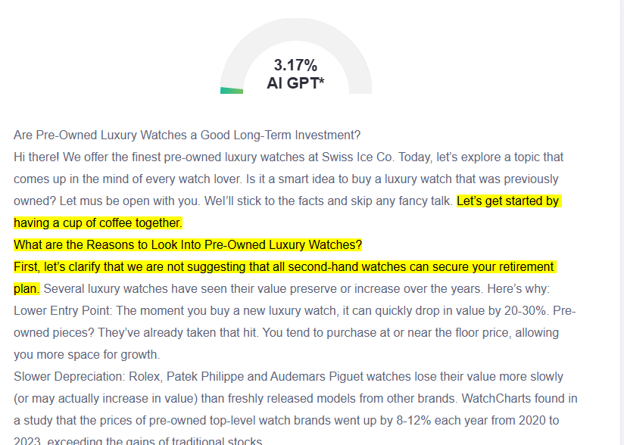

GMB
Purchasing a pre-owned luxury watch from Swiss Ice Co. often results in a watch that only appreciates in value. We offer timepieces from known brands such as Rolex, Patek Philippe, and Audemars Piguet. Watches of these companies increase in value by 8-12% each year, exceeding the performance of standard stocks. You can benefit from buying pre-owned watches. Models that are discontinued are likely to increase in value, such as the Rolex "Pepsi" GMT-Master II, which went up by 25% in just six months. We carry out a thorough 12-point authentication procedure for every watch sold here. We check to see if the watch is genuine, what its service history is like, and how well-maintained it is. You will get a digital copy of the repair history, previous owners, and detailed photographs. We also follow market trends that favor smart buyers. The value of pre-owned luxury watches increased by 65% from 2018 to 2023. More and more millennials are buying secondhand watches because they are interested in affordability and sustainability. Sports models typically hold value better than dress watches. The stainless steel Submariner, Nautilus, Royal Oak, Speedmaster Professional, and Tudor Black Bay GMT consistently perform well in the secondary market. Quality watches aren’t seen as just valuable things; they become part of your family’s heritage. If you get a Rolex today, it could be worth ten times its price in 2070, and your grandson could cherish it.

